


VEHICLE MANAGEMENT SYSTEM

PBL REPORT

Submitted by
ROHITH RAM R 2403730424321129
CHELIYAN S 2403730424321131
SAASMITHA C 2403730424322132

in partial fulfilment for the award of Internal Marks
23AD403 – DATABASE MANAGEMENT SYSTEM
in

B. TECH ARTIFICIAL INTELLIGENCE AND DATA SCIENCE

ERODE SENGUNTHAR ENGINEERING COLLEGE
(AUTONOMOUS)
PERUNDURAI, ERODE – 638057

May & 2026

ERODE SENGUNTHAR ENGINEERING COLLEGE
(AUTONOMOUS)
PERUNDURAI, ERODE – 638057

BONAFIDE CERTIFICATE

Certified that this project report “VEHICLE MANAGEMENT SYSTEM” is the bonafide work of “ROHITH RAM R (2403730424321129), CHELIYAN S (2403730424321131), SAASMITHA C (2403730424322132)” who carried out the project-based learning work under my guidance. Certified further that to the best of my knowledge.

SIGNATURE SIGNATURE
Ms. K. RAGAVI, M.E Dr. G. SARAVANAN, M.E, Ph.D
SUPERVISOR HEAD OF THE DEPARTMENT
Artificial Intelligence and Data Science Artificial Intelligence and Data Science
Erode Sengunthar Engineering College Erode Sengunthar Engineering College
Perundurai, Erode – 638057 Perundurai, Erode – 638057

Submitted for Project Based Learning Review 2 and Viva – Voce Examination held on ___________________________________________

Name and Signature of PBL Subject Faculty with Date

ABSTRACT
The Vehicle Service Management System is a database application developed to manage and organize vehicle service center operations efficiently. This system stores customer details, vehicle information, service records, billing details, spare parts information, and mechanic assignments in a structured database system. The project mainly focuses on reducing manual paperwork and improving the efficiency of service center management.
In many small and medium-scale vehicle service centers, records are maintained manually using paper registers or spreadsheets. This traditional method creates many problems such as data duplication, difficulty in searching records, billing calculation errors, and improper maintenance of service history. The manual system also consumes more time and increases the chances of data loss.
To overcome these limitations, the Vehicle Service Management System is developed using Database Management System concepts. The system stores data in relational tables with proper relationships between customer details, vehicle details, mechanic details, and service records. This improves data consistency, integrity, and security.
The proposed system provides various functionalities such as customer registration, vehicle registration, service booking, mechanic assignment, spare parts management, automated bill generation, and report generation. The system also helps service centers maintain service history records for future reference. By automating the service management process, the project improves accuracy, reduces paperwork, saves time, and enhances customer satisfaction.
The project demonstrates the importance of database systems in real-world applications and shows how DBMS concepts can be used effectively to manage business operations in an organized and efficient manner.

TABLE OF CONTENTS
CHAPTER NO. TITLE PAGE NO.
ABSTRACT 3
- INTRODUCTION 5
- STATEMENT OF PROJECT 7
- OBJECTIVE OF THE PROJECT and REQUIRMENT 8
- IMPLEMENTATION and WORKING PROCEDURE 10
- CONCLUSION and FUTURE SCOPE 12
- APPENDICES 13
  - Program Code (Sample) 13
  - Photos 15
    - Model of the Project 15
    - First Review Photos 16
- REFERENCE 19

CHAPTER 1
INTRODUCTION
Vehicle service centers play an important role in maintaining vehicles and ensuring customer satisfaction. In many small and medium-scale service centers, customer records, service details, billing information, and spare parts details are maintained manually using paper registers or spreadsheets. This manual process creates many difficulties in managing large amounts of data efficiently.
Manual systems often lead to problems such as data duplication, improper record maintenance, billing calculation errors, and difficulty in retrieving information quickly. Service history records may also get lost or damaged over time. Searching old records becomes time-consuming and inefficient. These problems reduce the overall performance of service center operations.
To overcome these issues, the Vehicle Service Management System is developed using Database Management System concepts. The system helps in storing and managing data in a structured and organized format. The project allows service centers to maintain customer details, vehicle information, service records, mechanic assignments, spare parts details, and billing information digitally.
The proposed system provides better accuracy and reduces manual paperwork significantly. Since the data is stored in a relational database, it becomes easier to search, update, and retrieve records quickly. The system also improves data security and consistency through proper database relationships and constraints.
The Vehicle Service Management System contains various modules such as customer registration, vehicle registration, service management, billing system, mechanic assignment, and report generation. Each module performs a specific function and contributes to the overall working of the system.
The project mainly focuses on improving operational efficiency and customer satisfaction in vehicle service centers. The use of computerized systems helps save time and minimizes human errors. Automated billing and report generation features further simplify the management process.
This project demonstrates how DBMS concepts such as primary keys, foreign keys, normalization, and relational tables can be applied in real-world applications. The system helps service centers manage their operations in a more organized, secure, and efficient manner.

CHAPTER 2
STATEMENT OF PROJECT
The Vehicle Service Management System is developed to solve the problems faced by vehicle service centers while maintaining records manually. Many service centers still depend on paper-based registers or spreadsheets to store customer details, vehicle information, service records, and billing data. These traditional methods are inefficient and create several management issues.
Manual systems consume more time and increase paperwork. Searching customer records or service history becomes difficult and time-consuming. Billing calculations may contain errors, leading to customer dissatisfaction and financial problems. There is also a high risk of data loss due to improper maintenance of records.
Another major issue in the existing system is data redundancy. The same information may be entered multiple times, causing duplication and inconsistency in records. Security is also weak in manual systems because unauthorized persons can access or modify records easily.
The proposed Vehicle Service Management System solves these problems by introducing a computerized database application. The system stores all information in a structured database and allows users to access data quickly and accurately. The use of relational tables ensures data consistency and integrity.
The project provides features such as customer registration, vehicle registration, service tracking, mechanic assignment, spare parts management, automated billing, and report generation. These features improve operational efficiency and reduce manual effort.
The computerized system also improves security by restricting unauthorized access. Service history can be maintained properly for future reference, and reports can be generated automatically whenever required. Overall, the project aims to improve service center management through automation and database technology.

CHAPTER 3
OBJECTIVE OF THE PROJECT AND FUTURE SCOPE
Objectives of the Project
The main objectives of the Vehicle Service Management System are:
- To design and develop a database system for vehicle service management.
- To store customer and vehicle details efficiently.
- To maintain complete service history records.
- To reduce manual paperwork and human errors.
- To generate accurate billing information automatically.
- To manage mechanic assignments effectively.
- To improve data security and consistency.
- To provide fast retrieval and updating of records.
- To simplify spare parts management.
- To improve customer satisfaction through better service management.
Functional Requirements
The functional requirements of the system include:
- Customer Registration Module
- Vehicle Registration Module
- Service Booking Module
- Mechanic Assignment Module
- Billing Module
- Spare Parts Management Module
- Report Generation Module
- Login and Authentication System
Non-Functional Requirements
The non-functional requirements include:
- Data Security
- Fast Processing Speed
- Reliability
- Scalability
- User-Friendly Interface
- Data Accuracy
Hardware Requirements
Component | Requirement
Processor | Intel i3 or above
RAM | Minimum 4 GB
Hard Disk | 500 GB
Monitor | Standard Display
Keyboard & Mouse | Required
Software Requirements
Software | Description
HTML | Front-End Design
CSS | Styling
JavaScript | Client-Side Validation
Node.js | Server-Side Development
VS Code | Code Editor

CHAPTER 4
IMPLEMENTATION AND WORKING PROCEDURE
Implementation
The Vehicle Service Management System is implemented using web technologies and database concepts. The front-end of the application is developed using HTML, CSS, and JavaScript. The back-end operations are managed using Node.js. The system stores information in a structured format for efficient management.
The implementation process includes designing tables, creating relationships, developing modules, and testing the system. Different modules are connected together to perform complete service management operations.
Modules of the System
1. Customer Registration Module
2. Vehicle Registration Module
3. Service Management Module
4. Mechanic Assignment Module
5. Billing Module
6. Spare Parts Management Module
7. Report Generation Module
Working Procedure
Step 1: Customer Registration
Step 2: Vehicle Registration
Step 3: Service Request
Step 4: Mechanic Assignment
Step 5: Service Process
Step 6: Spare Parts Update
Step 7: Bill Generation
System Benefits
- Easy management of records
- Quick searching of data
- Reduced manual errors
- Better service tracking
- Secure storage of information
- Improved efficiency

CHAPTER 5
CONCLUSION AND FUTURE SCOPE
Conclusion
The Vehicle Service Management System is an effective database application developed to improve the efficiency of vehicle service center operations. The project successfully reduces manual paperwork and simplifies record management through automation.
The system stores customer details, vehicle information, service records, billing information, and mechanic assignments in an organized database structure. It improves data consistency, security, and retrieval speed. Automated billing and report generation features save time and reduce calculation errors.
The project demonstrates the practical implementation of DBMS concepts such as relational tables, primary keys, foreign keys, normalization, and data relationships. The system provides better operational efficiency and improves customer satisfaction.
Overall, the Vehicle Service Management System is a reliable and efficient solution for modern vehicle service centers.
Future Scope
The future enhancements of the project may include:
- Online appointment booking system
- Mobile application support
- SMS and email notifications
- Online payment integration
- Cloud database storage
- AI-based service prediction
- Barcode system for spare parts
- Multi-branch service center management
These improvements can make the system more advanced and user-friendly.

CHAPTER 6
APPENDICES
6.1 Program Code
The following is a simplified, conceptual Python code snippet illustrating the core workflow of the Vehicle Management System. It uses placeholder libraries to demonstrate intent classification and response generation. Note that this is a high-level simulation and not the production-level code.
HTML
<!DOCTYPE html>
<html>
<head>
<title>Vehicle Service Management</title>
</head>
<body>
<h1>Vehicle Service Center</h1>
<form>
<label>Customer Name:</label>
<input type="text"><br><br>
<label>Vehicle Number:</label>
<input type="text"><br><br>
<button type="submit">Submit</button>
</form>
</body>
</html>

CSS
body{
font-family: Arial;
background-color: #f2f2f2;
}
h1{
color: blue;
}
form{
background: white;
padding: 20px;
}
JavaScript
const express = require('express');
const app = express();
app.get('/', (req, res) => {
res.send('Vehicle Service Management System');
});
app.listen(3000, () => {
console.log('Server running on port 3000');
});

6.2 Photos
6.2.1 Model of the Project
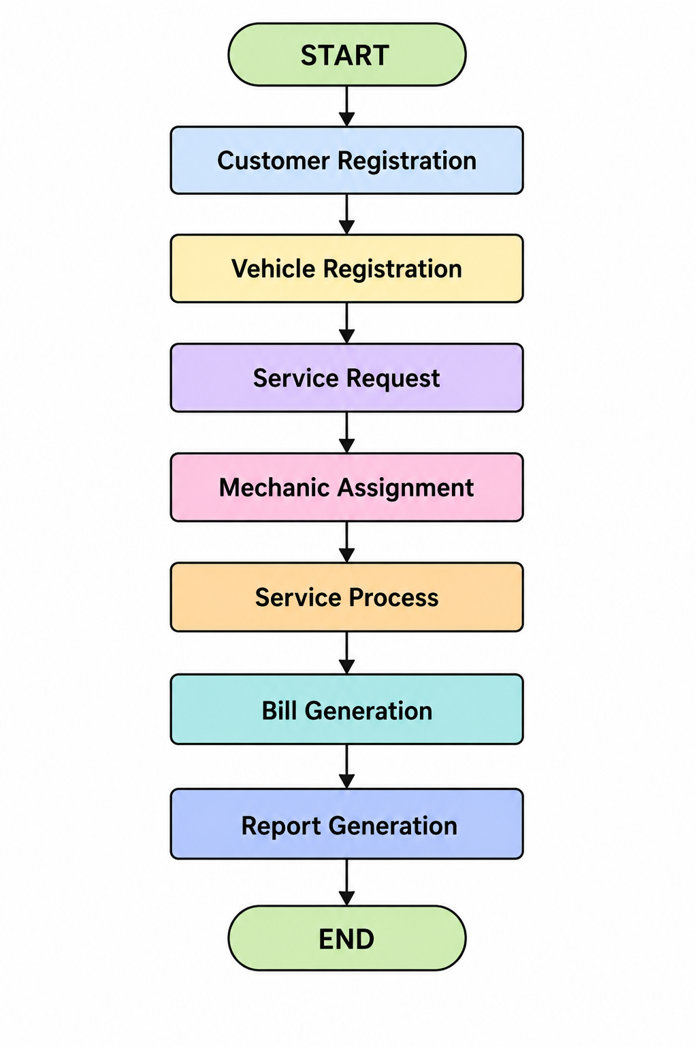

6.2.2 First Review Photos
The following photographs are the output of our project
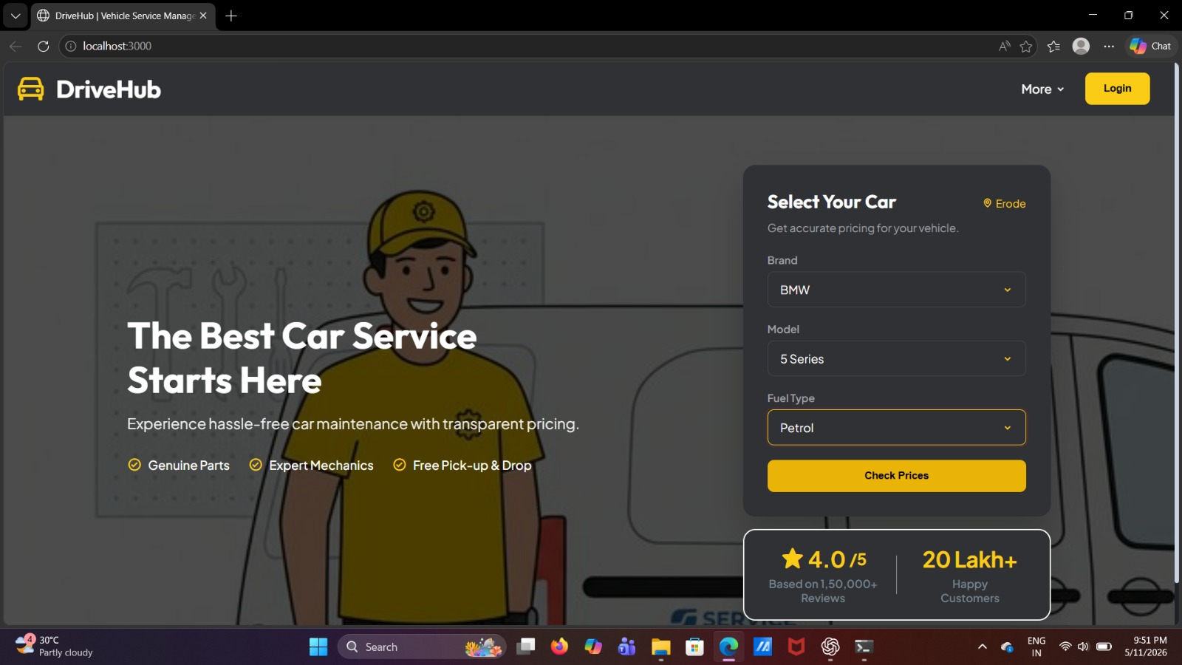

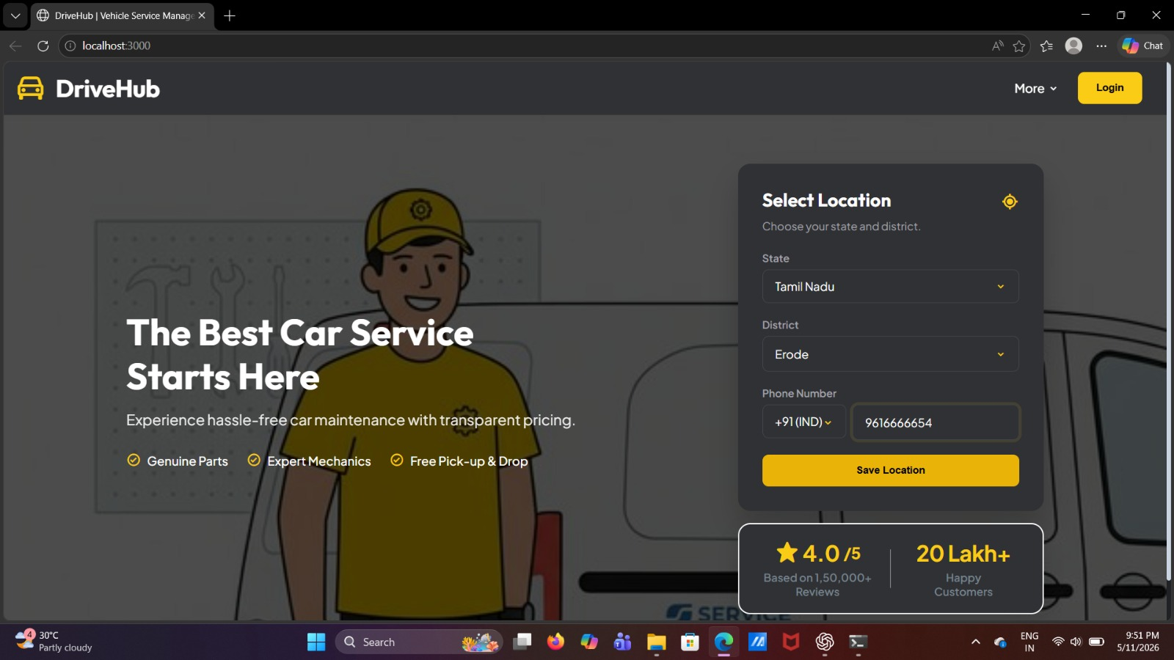

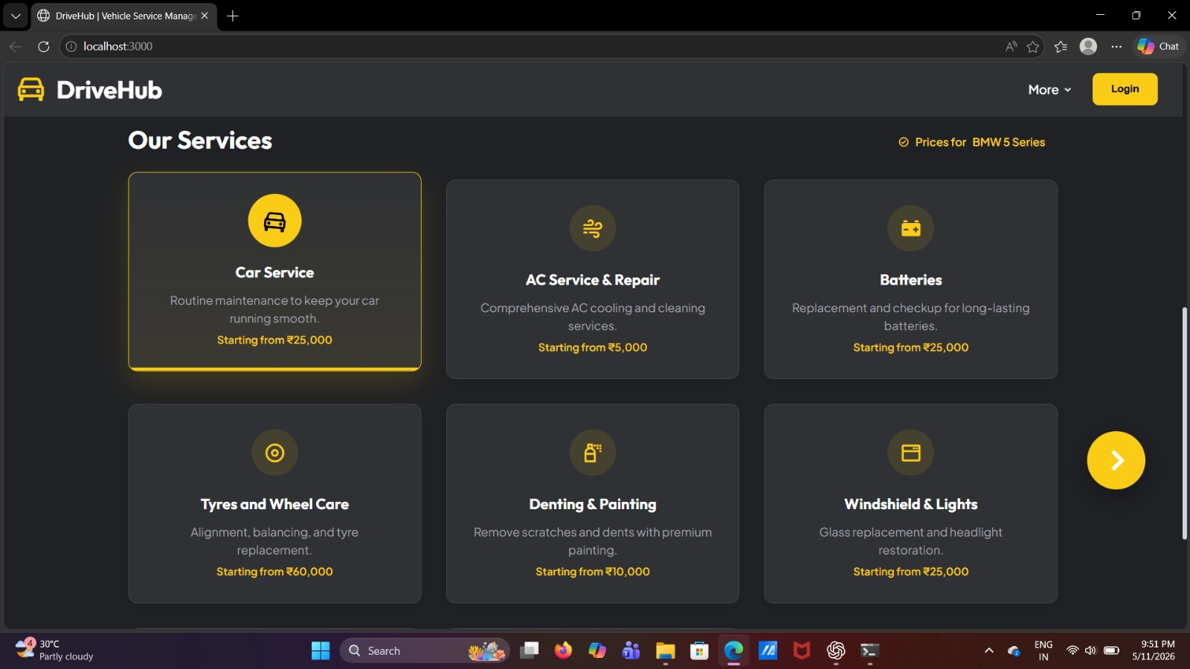

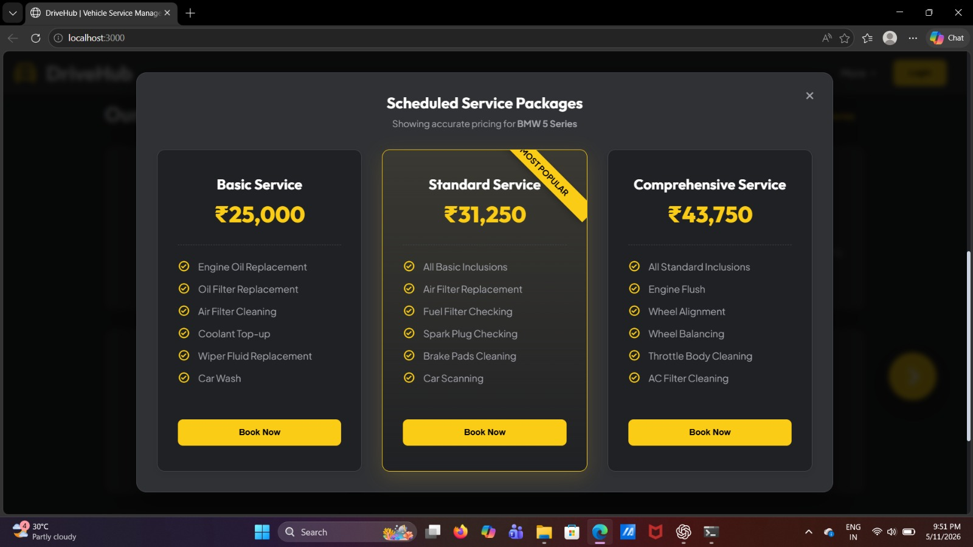
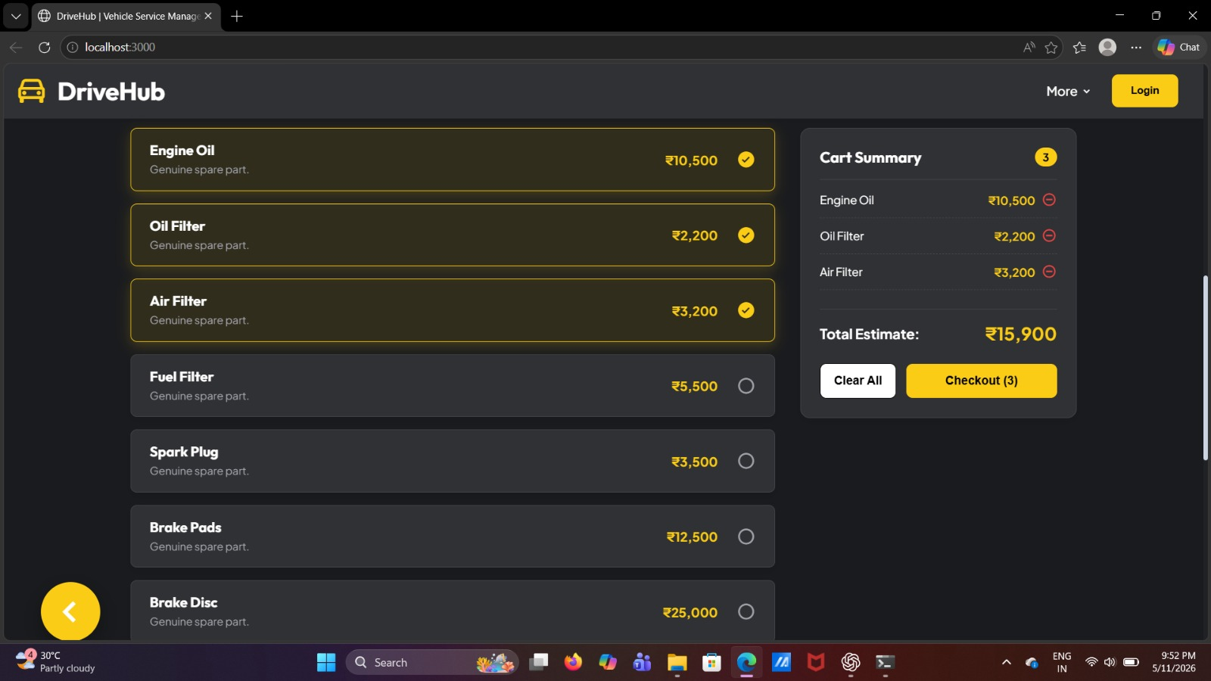
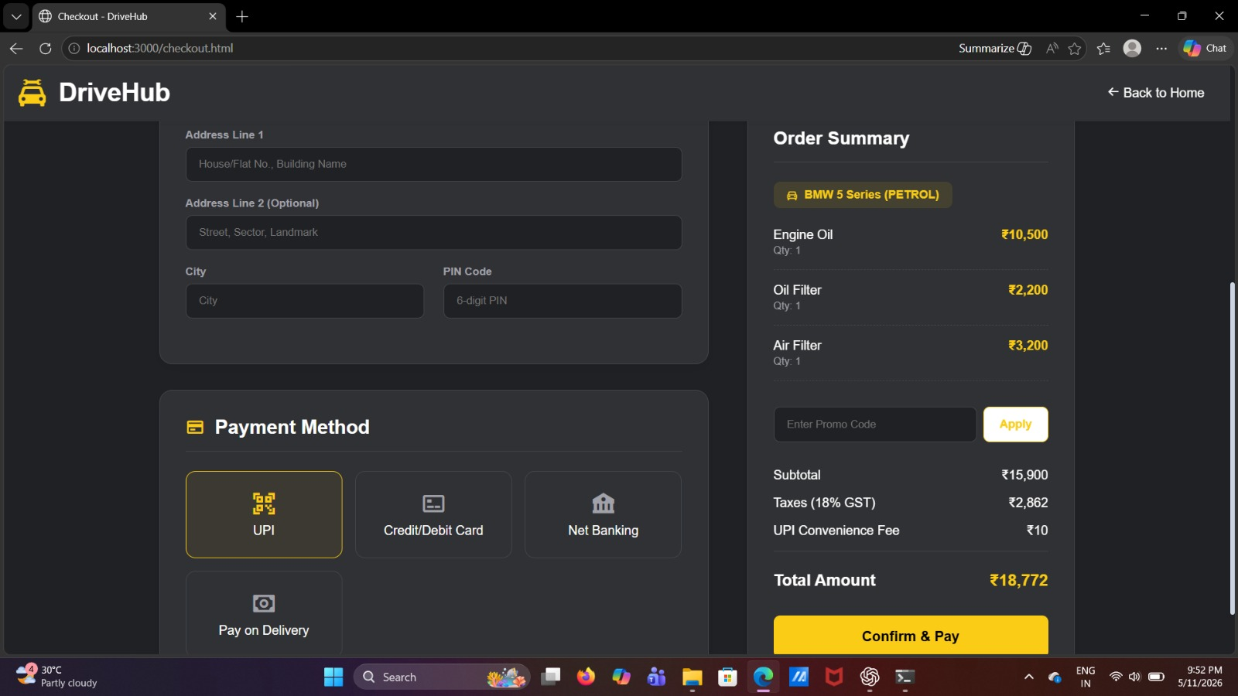

Each photograph has been assigned a descriptive caption and a figure number for clear identification and reference within the document.
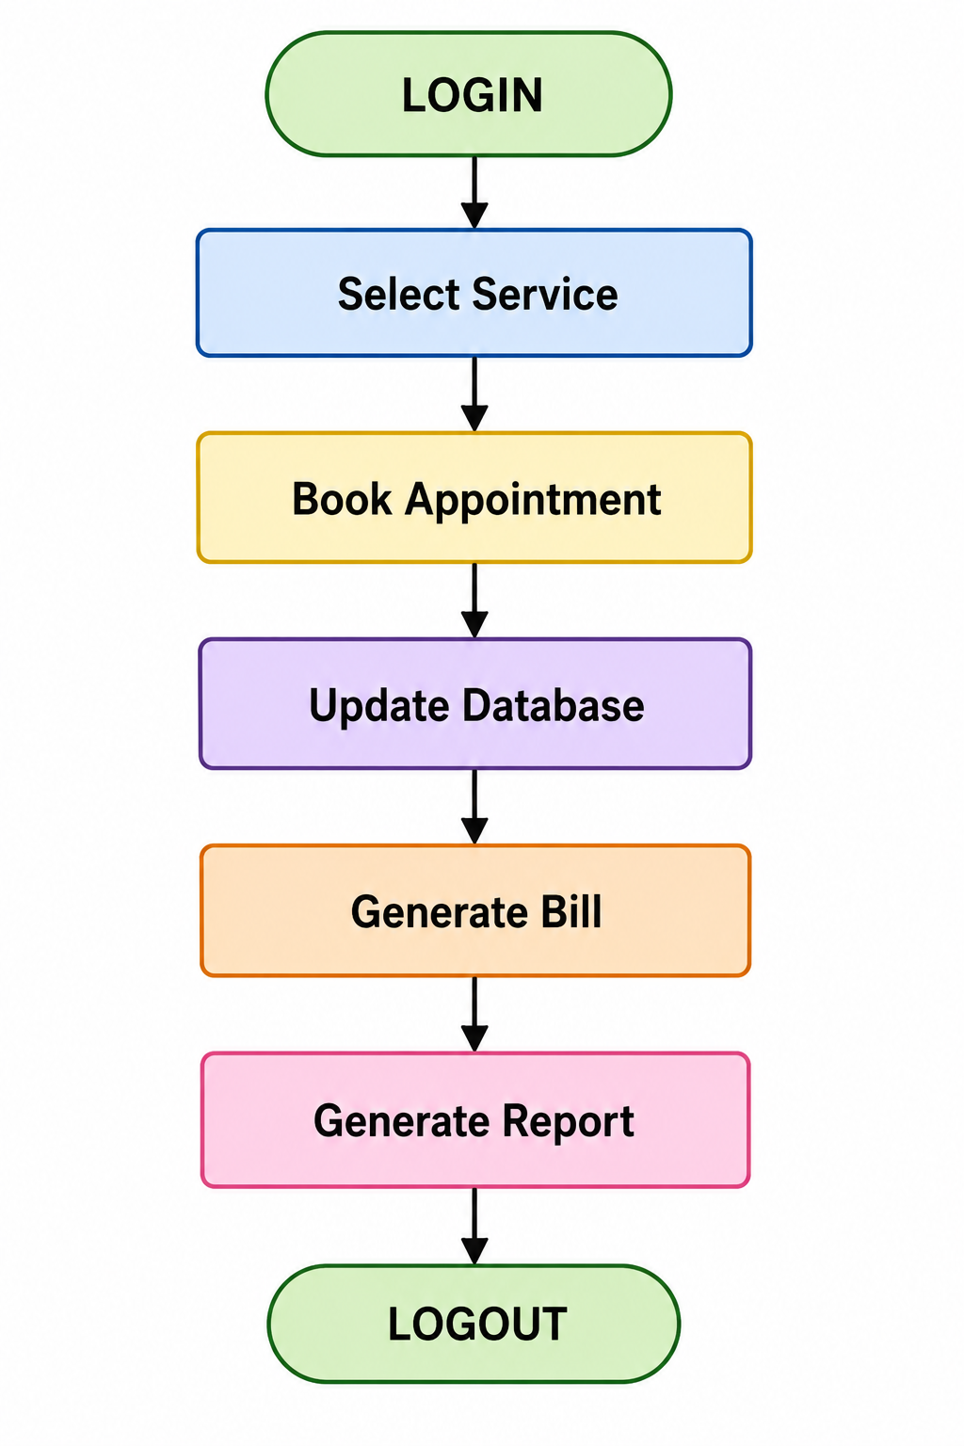
CHAPTER 7
REFERENCE
- Database System Concepts — Abraham Silberschatz, Henry F. Korth, and S. Sudarshan, Database System Concepts, McGraw-Hill Education.
- Fundamentals of Database Systems — Ramez Elmasri and Shamkant B. Navathe, Fundamentals of Database Systems, Pearson Education.
- Node.js Official Documentation
- MDN Web Docs – HTML, CSS and JavaScript
- W3Schools Web Development Tutorials
- C. J. Date, An Introduction to Database Systems, Addison-Wesley.
- Research papers and online articles related to vehicle service management systems and database applications.

